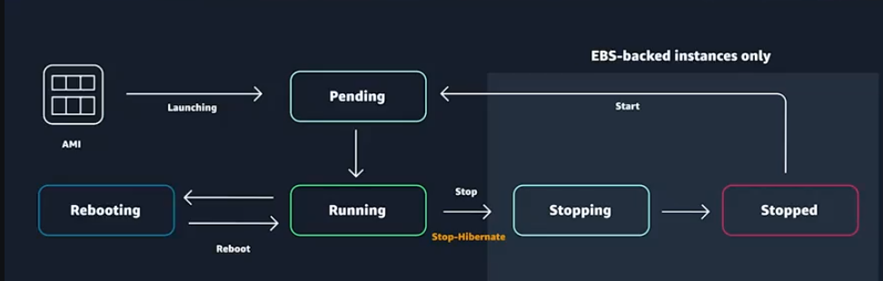
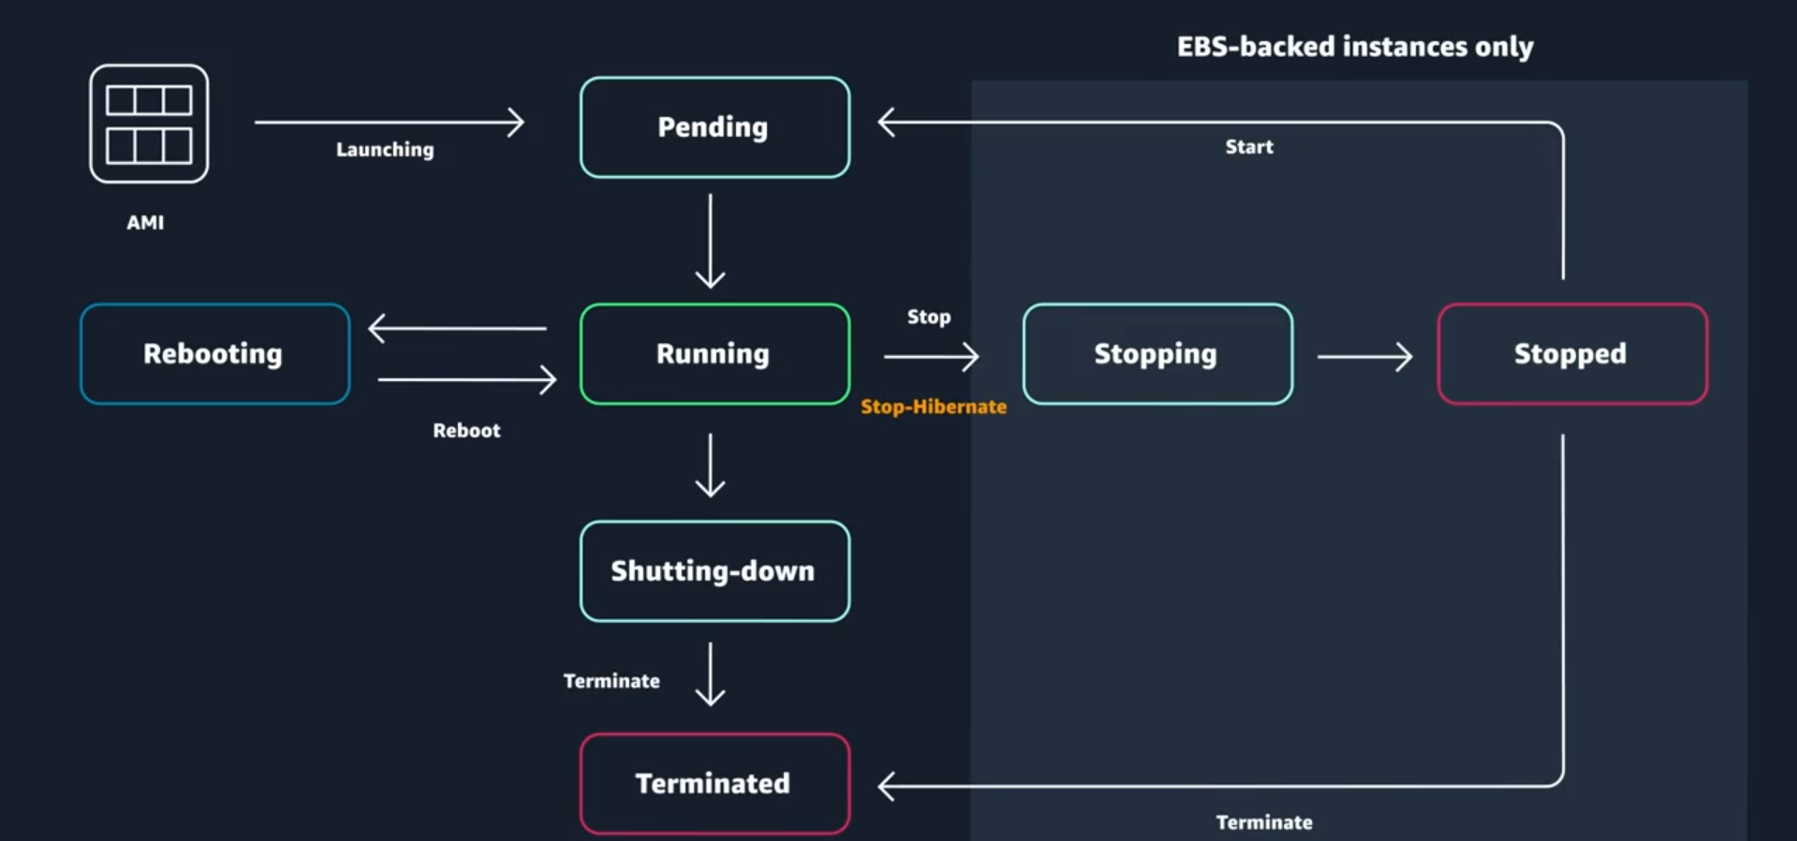

Here’s a concise bullet-point summary of Reading 2.25: Amazon EC2 Instance Lifecycle:
🔹 Configuring EC2 Instances
- After selecting the operating system, configure:
  - Instance type (CPU, memory, network, storage, GPU if needed).
  - Network settings (VPC, subnets, security groups).
  - Storage options (EBS volumes, instance storage).
- Instance sizing depends on:
  - Application demands.
  - Anticipated user base size.
🔹 Cloud vs. On-Premises
- On-premises: requires upfront capital spending and complex capacity forecasting.
- AWS Cloud: capacity adjustments are simple (via API calls).
- Pay-as-you-go model: infrastructure scales with demand, reducing waste and cost.
🔹 What Makes Up an EC2 Instance
- Components include:
  - vCPUs (virtual processors).
  - Memory (RAM).
  - Networking capacity.
  - Instance storage (optional).
  - GPUs (for compute-intensive workloads).
🔹 Instance Types
- AWS offers a wide variety of instance families optimized for different workloads.
- Instance type naming convention:
  - Prefix → workload family + generation (e.g., c5).
    - c = compute-optimized family.
    - 5 = fifth generation.
  - Size → capacity level (e.g., large).
- Example: c5.large
  - c5 → compute-optimized, 5th generation.
  - large → specific capacity size.

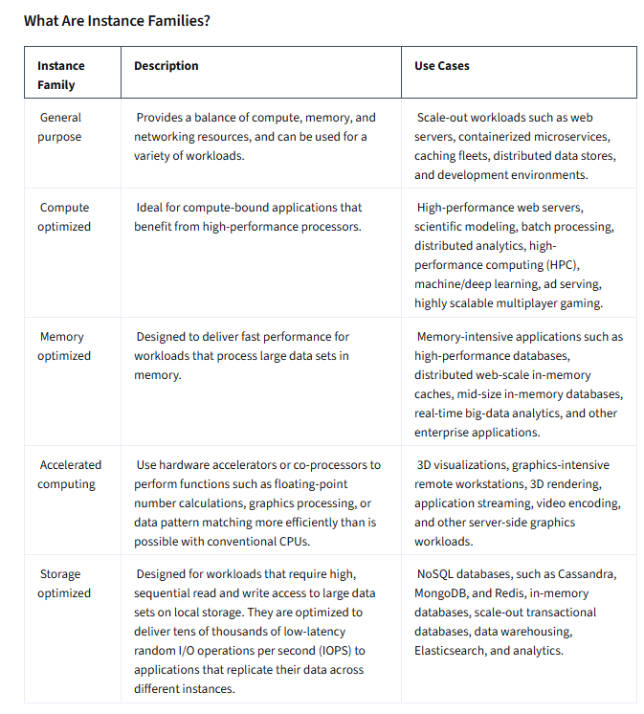

Here’s a structured bullet-point summary of Where Does Your EC2 Instance Live? & Lifecycle Concepts:
🔹 Default VPC
- By default, EC2 instances are placed in the default Amazon VPC.
- Default VPC makes it easy to start without networking knowledge.
- Warning: resources in the default VPC are publicly accessible → avoid storing sensitive data.
- Best practice: create custom VPCs with restricted access, routing, and connectivity controls.
🔹 High Availability Architecture
- Instances reside in Availability Zones (AZs).
- For reliability, use multiple instances across multiple AZs.
- Strategy:
  - Prefer many smaller instances over a few large ones.
  - Example: 10 instances → losing 1 affects only 10% of capacity.
- Minimum recommendation: at least two instances in two AZs.
🔹 EC2 Instance Lifecycle States
- Pending → preparing resources, AMI copied, networking allocated (billing not started).
- Running → instance ready, billing begins.
  - Actions possible: reboot, stop, stop-hibernate, terminate.
- Reboot → like OS reboot; same host, same IPs, data preserved.
- Stop/Start → may move to new host; public IP changes, private IP remains; instance store data lost.
- Terminate → instance deleted; both public & private IPs lost; instance store erased.
🔹 Stop vs. Stop-Hibernate
- Stop:
  - Instance halts, enters stopped state.
  - No compute billing, but EBS storage billed.
  - RAM data lost.
- Stop-Hibernate:
  - RAM contents saved to EBS root volume.
  - Useful for workloads needing in-memory persistence (e.g., caching layers).
  - Saves effort of manual RAM data backup.
🔹 EC2 Pricing Basics
- Billing per second (shown per hour for simplicity).
- Example: 5 min 38 sec → pay for 338 seconds.
- Exception: some third-party Marketplace AMIs → minimum 1-hour billing.
- Pricing = instance cost (specs) + storage/networking costs.
🔹 EC2 Pricing Options
- On-Demand Instances
  - Pay-as-you-go, no commitments.
  - Fixed per-second price.
  - Best for short-term, unpredictable workloads.
  - Less cost-effective for always-on servers.
- Reserved Instances (RIs)
  - 1-year or 3-year commitment.
  - Discounts vs. On-Demand.
  - Payment options: All Upfront > Partial Upfront > No Upfront (descending discount).
  - Still billed even if stopped (due to commitment).
  - Discounts tied to instance type & AZ, not specific instance ID.
- Spot Instances
  - Up to 90% discount vs. On-Demand.
  - Use unused AWS capacity.
  - You set max price; AWS allocates if below Spot price.
  - Risk: interruption (2-minute warning).
  - Best for fault-tolerant workloads: big data, CI/CD, HPC, rendering, test/dev.

